Fractional Integration Hypothesis Test
- Methods of Testing
  - Fractional Dickey Fuller.
    - General Description:
Tests the following hypothesis:
Given a process y_{t} defined as ARFIMA(p,d,q) process:
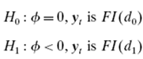, where d₀ =1, d₁ ε (0, 1/2)
Based on the OLS regression of the following:
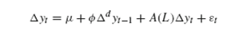.
    - Pros: Objectively test for fractional integration for finite sample. Have code that calculates critical values for FDF test in Matlab, which uses MARS and specification of lag, T, type.
    - Cons: Relatively inefficient test for ½ < d < 1.

  - Lobato and Valesco Wald Test

